**EXPERIMENT 9**

By,

**Raja Aadhithan**

**19/1031**

**Write a MATLAB Script to find the phase angle, phase delay and phase response of the designed IIR filters Lab6.**

**Code:**

clc

clear

disp('The type of Windows are: 1.Rectangular 2.Hamming 3.Hann 4.Kaiser')

c=input('Choose the type of Window: ');

disp('Enter the type of filter')

disp('1. Low pass 2.High Pass 3. Bandpass filter 4. Bandstop filter')

d=input('Choose the filter type: ');

n=input('Enter the order of the filter: ');

wn=input('Enter the frequency: ');

n1=input('Enter the number of evaluation points: ');

nm=mod(n,2);

if nm==1

n=n+1;

end

if c==1

if d==1

b = fir1(n ,wn,'low',rectwin(n+1));

freqz(b,1,n1);

title('Low Pass Filter with Rectangular Window');

elseif d==2

b = fir1(n ,wn,'high',rectwin(n+1));

freqz(b,1,n1);

title('High Pass Filter with Rectangular Window');

theta = angle(z);

elseif d==3

b = fir1(n ,wn,'pass',rectwin(n+1));

freqz(b,1,n1);

title('Bandpass Filter with Rectangular Window');

elseif d==4

b = fir1(n ,wn,'stop',rectwin(n+1));

freqz(b,1,n1);

title('Bandstop Filter with Rectangular Window');

end

elseif c==2

if d==1

b= fir1(n,wn,'low',hamming(n+1));

freqz(b,1,n1);

title('Low Pass Filter with Hamming Window');

elseif d==2

b= fir1(n,wn,'high',hamming(n+1));

freqz(b,1,n1);

title('High Pass Filter with Hamming Window');

elseif d==3

b= fir1(n,wn,'pass',hamming(n+1));

freqz(b,1,n1);

title('Bandpass Filter with Hamming Window');

elseif d==4

b= fir1(n,wn,'stop',hamming(n+1));

freqz(b,1,n1);

title('Bandstop Filter with Hamming Window');

end

elseif c==3

if d==1

b= fir1(n,wn,'low',hann(n+1));

freqz(b,1,n1);

title('Low Pass Filter with Hann Window');

elseif d==2

b= fir1(n,wn,'high',hann(n+1));

freqz(b,1,n1);

title('High Pass Filter with Hann Window');

elseif d==3

b= fir1(n,wn,'pass',hann(n+1));

freqz(b,1,n1);

title('Bandpass Filter with Hann Window');

elseif d==4

b= fir1(n,wn,'stop',hann(n+1));

freqz(b,1,n1);

title('Bandstop Filter with Hann Window');

end

elseif c==4

if d==1

b= fir1(n,wn,'low',kaiser(n+1));

freqz(b,1,n1);

title('Low Pass Filter with Kaiser Window');

elseif d==2

b= fir1(n,wn,'high',kaiser(n+1));

freqz(b,1,n1);

title('High Pass Filter with Kaiser Window');

elseif d==3

b= fir1(n,wn,'pass',kaiser(n+1));

freqz(b,1,n1);

title('Bandpass Filter with Kaiser Window');

elseif d==4

b= fir1(n,wn,'stop',kaiser(n+1));

freqz(b,1,n1);

title('Bandstop Filter with Kaiser Window');

else

disp('Invalid input');

end

end

figure(2);

phasedelay(b,512);

title('Phase delay of the designed filter');

figure(3);

phasez(b);

title('Phase Response of the designed filter');

z = freqz(b,1);

theta = angle(z);

theta = theta';

disp('Phase of designed filter: ');

disp(theta);

**Output :**

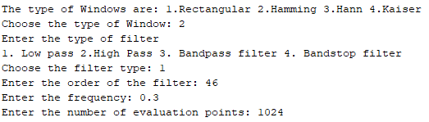

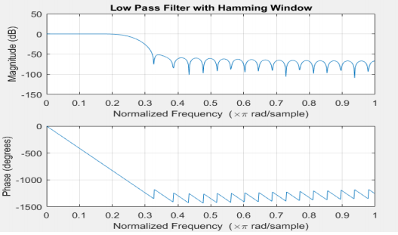

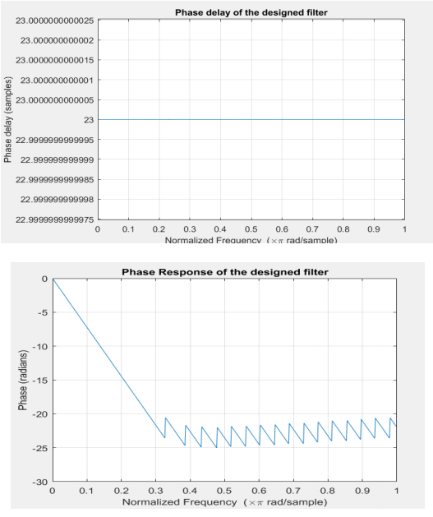

**Write a MATLAB Script to find the phase angle, phase delay and phase response of the designed IIR filters Lab7.**

**Code:**

clc;

clear;

close all;

type = input('Enter the type of filter(1. Low Pass, 2. High Pass, 3. Band Pass, 4. Band Stop): ');

g = input('Enter the design of filter(1.Butterworth , 2.Chebyshev type1 , 3. Chebyshev type2 , 4. Elliptic): ');

k = input('Enter the type of Filter discretization functions(1. Bilinear, 2. Impulse Invariant): ');

rp = input('Enter the pass band ripple: ');

rs = input('Enter the stop band attenuation: ');

wp = input('Enter the pass band frequency(Hz): ');

ws = input('Enter the stop band frequency(Hz): ');

fs = input('Enter the sampling frequency(Hz): ');

wp = wp/(fs/2);

ws = ws/(fs/2);

if(type == 1)

if(g == 1)

[n,wn] = buttord(wp,ws,rp,rs);

[b,a] = butter(n,wn,'low');

if(k ==1)

[bz,az] = bilinear(b,a,fs);

elseif(k==2)

[bz,az] = impinvar(b,a,fs);

end

freqz(bz,az,1024,fs);

title(sprintf('n = %d Digital Low Pass Butterworth Filter',n));

figure(2);

freqz(b,a,1024,fs);

title(sprintf('n = %d Analog Low Pass Butterworth Filter',n));

elseif(g == 2)

[n,wp] = cheb1ord(wp,ws,rp,rs);

[b,a] = cheby1(n,rp,wp,'low');

if(k ==1)

[bz,az] = bilinear(b,a,fs);

elseif(k==2)

[bz,az] = impinvar(b,a,fs);

end

freqz(bz,az,1024,fs);

title(sprintf('n = %d Digital Low Pass Chebyshev Type 1 Filter',n));

figure(2);

freqz(b,a,1024,fs);

title(sprintf('n = %d Analog Low Pass Chebyshev Type 1 Filter',n));

elseif(g == 3)

[n,ws] = cheb2ord(wp,ws,rp,rs);

[b,a] = cheby2(n,rs,ws,'low');

if(k ==1)

[bz,az] = bilinear(b,a,fs);

elseif(k==2)

[bz,az] = impinvar(b,a,fs);

end

freqz(bz,az,1024,fs);

title(sprintf('n = %d Digital Low Pass Chebyshev Type 2 Filter',n));

figure(2);

freqz(b,a,1024,fs);

title(sprintf('n = %d Analog Low Pass Chebyshev Type 2 Filter',n));

elseif(g == 4)

[n,wp] = ellipord(wp,ws,rp,rs);

[b,a] = ellip(n,rp,rs,wp,'low');

if(k ==1)

[bz,az] = bilinear(b,a,fs);

elseif(k==2)

[bz,az] = impinvar(b,a,fs);

end

freqz(bz,az,1024,fs);

title(sprintf('n = %d Digital Low Pass Elliptic Filter',n));

figure(2);

freqz(b,a,1024,fs);

title(sprintf('n = %d Analog Low Pass Elliptic Filter',n));

end

elseif(type == 2)

if(g == 1)

[n,wn] = buttord(wp,ws,rp,rs);

[b,a] = butter(n,wn,'high');

if(k ==1)

[bz,az] = bilinear(b,a,fs);

elseif(k==2)

[bz,az] = impinvar(b,a,fs);

end

freqz(bz,az,1024,fs);

title(sprintf('n = %d Digital High Pass Butterworth Filter',n));

figure(2);

freqz(b,a,1024,fs);

title(sprintf('n = %d Analog High Pass Butterworth Filter',n));

elseif(g == 2)

[n,wp] = cheb1ord(wp,ws,rp,rs);

[b,a] = cheby1(n,rp,wp,'high');

if(k ==1)

[bz,az] = bilinear(b,a,fs);

elseif(k==2)

[bz,az] = impinvar(b,a,fs);

end

freqz(bz,az,1024,fs);

title(sprintf('n = %d Digital High Pass Chebyshev Type 1 Filter',n));

figure(2);

freqz(b,a,1024,fs);

title(sprintf('n = %d Analog High Pass Chebyshev Type 1 Filter',n));

elseif(g == 3)

[n,ws] = cheb2ord(wp,ws,rp,rs);

[b,a] = cheby2(n,rs,ws,'high');

if(k ==1)

[bz,az] = bilinear(b,a,fs);

elseif(k==2)

[bz,az] = impinvar(b,a,fs);

end

freqz(bz,az,1024,fs);

title(sprintf('n = %d Digital High Pass Chebyshev Type 2 Filter',n));

figure(2);

freqz(b,a,1024,fs);

title(sprintf('n = %d Analog High Pass Chebyshev Type 2 Filter',n));

elseif(g == 4)

[n,wp] = ellipord(wp,ws,rp,rs);

[b,a] = ellip(n,rp,rs,wp,'high');

if(k ==1)

[bz,az] = bilinear(b,a,fs);

elseif(k==2)

[bz,az] = impinvar(b,a,fs);

end

freqz(bz,az,1024,fs);

title(sprintf('n = %d Digital High Pass Elliptic Filter',n));

figure(2);

freqz(b,a,1024,fs);

title(sprintf('n = %d Analog High Pass Elliptic Filter',n));

end

elseif(type == 3)

if(g == 1)

[n,wn] = buttord(wp,ws,rp,rs);

[b,a] = butter(n,wn,'bandpass');

if(k ==1)

[bz,az] = bilinear(b,a,fs);

elseif(k==2)

[bz,az] = impinvar(b,a,fs);

end

freqz(bz,az,1024,fs);

title(sprintf('n = %d Digital Bandpass Butterworth Filter',n));

figure(2);

freqz(b,a,1024,fs);

title(sprintf('n = %d Analog Bandpass Butterworth Filter',n));

elseif(g == 2)

[n,wp] = cheb1ord(wp,ws,rp,rs);

[b,a] = cheby1(n,rp,wp,'bandpass');

if(k ==1)

[bz,az] = bilinear(b,a,fs);

elseif(k==2)

[bz,az] = impinvar(b,a,fs);

end

freqz(bz,az,1024,fs);

title(sprintf('n = %d Digital Bandpass Chebyshev Type 1 Filter',n));

figure(2);

freqz(b,a,1024,fs);

title(sprintf('n = %d Analog Bandpass Chebyshev Type 1 Filter',n));

elseif(g == 3)

[n,ws] = cheb2ord(wp,ws,rp,rs);

[b,a] = cheby2(n,rs,ws,'bandpass');

if(k ==1)

[bz,az] = bilinear(b,a,fs);

elseif(k==2)

[bz,az] = impinvar(b,a,fs);

end

freqz(bz,az,1024,fs);

title(sprintf('n = %d Digital Bandpass Chebyshev Type 2 Filter',n));

figure(2);

freqz(b,a,1024,fs);

title(sprintf('n = %d Analog Bandpass Chebyshev Type 2 Filter',n));

elseif(g == 4)

[n,wp] = ellipord(wp,ws,rp,rs);

[b,a] = ellip(n,rp,rs,wp,'bandpass');

if(k ==1)

[bz,az] = bilinear(b,a,fs);

elseif(k==2)

[bz,az] = impinvar(b,a,fs);

end

freqz(bz,az,1024,fs);

title(sprintf('n = %d Digital Bandpass Elliptic Filter',n));

figure(2);

freqz(b,a,1024,fs);

title(sprintf('n = %d Analog Bandpass Elliptic Filter',n));

end

elseif(type == 4)

if(g == 1)

[n,wn] = buttord(wp,ws,rp,rs);

[b,a] = butter(n,wn,'stop');

if(k ==1)

[bz,az] = bilinear(b,a,fs);

elseif(k==2)

[bz,az] = impinvar(b,a,fs);

end

freqz(bz,az,1024,fs);

title(sprintf('n = %d Digital Bandstop Butterworth Filter',n));

figure(2);

freqz(b,a,1024,fs);

title(sprintf('n = %d Analog Bandstop Butterworth Filter',n));

elseif(g == 2)

[n,wp] = cheb1ord(wp,ws,rp,rs);

[b,a] = cheby1(n,rp,wp,'stop');

if(k ==1)

[bz,az] = bilinear(b,a,fs);

elseif(k==2)

[bz,az] = impinvar(b,a,fs);

end

freqz(bz,az,1024,fs);

title(sprintf('n = %d Digital Bandstop Chebyshev Type 1 Filter',n));

figure(2);

freqz(b,a,1024,fs);

title(sprintf('n = %d Analog Bandstop Chebyshev Type 1 Filter',n));

elseif(g == 3)

[n,ws] = cheb2ord(wp,ws,rp,rs);

[b,a] = cheby2(n,rs,ws,'stop');

if(k ==1)

[bz,az] = bilinear(b,a,fs);

elseif(k==2)

[bz,az] = impinvar(b,a,fs);

end

freqz(bz,az,1024,fs);

title(sprintf('n = %d Digital Bandstop Chebyshev Type 2 Filter',n));

figure(2);

freqz(b,a,1024,fs);

title(sprintf('n = %d Analog Bandstop Chebyshev Type 2 Filter',n));

elseif(g == 4)

[n,wp] = ellipord(wp,ws,rp,rs);

[b,a] = ellip(n,rp,rs,wp,'stop');

if(k ==1)

[bz,az] = bilinear(b,a,fs);

elseif(k==2)

[bz,az] = impinvar(b,a,fs);

end

freqz(bz,az,1024,fs);

title(sprintf('n = %d Digital Bandstop Elliptic Filter',n));

figure(2);

freqz(b,a,1024,fs);

title(sprintf('n = %d Analog Bandstop Elliptic Filter',n));

end

end

figure(3);

phasedelay(bz,az,512);

title('Phase delay of the designed filter');

figure(4);

phasez(bz,az);

title('Phase Response of the designed filter');

z = freqz(b,a,1024,fs);

theta = angle(z);

theta = theta';

disp('Phase of designed filter: ');

disp(theta);

